Steps to launch an instance in GCP:

Step 1: Once you are on the console, click on Compute Engine under Compute on the left menu. Click on VM Instances from the drop down menu

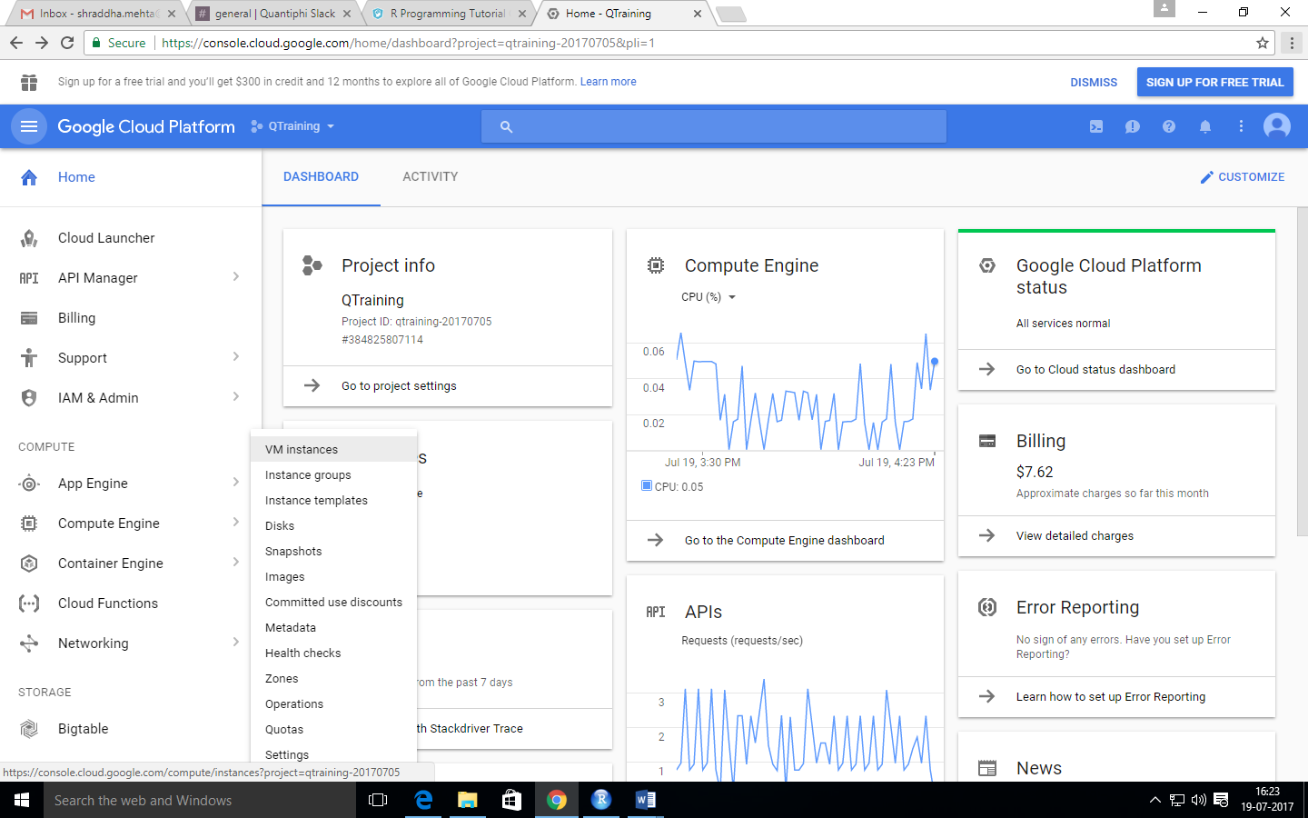

Step 2: Click on the CREATE INSTANCE option on the top

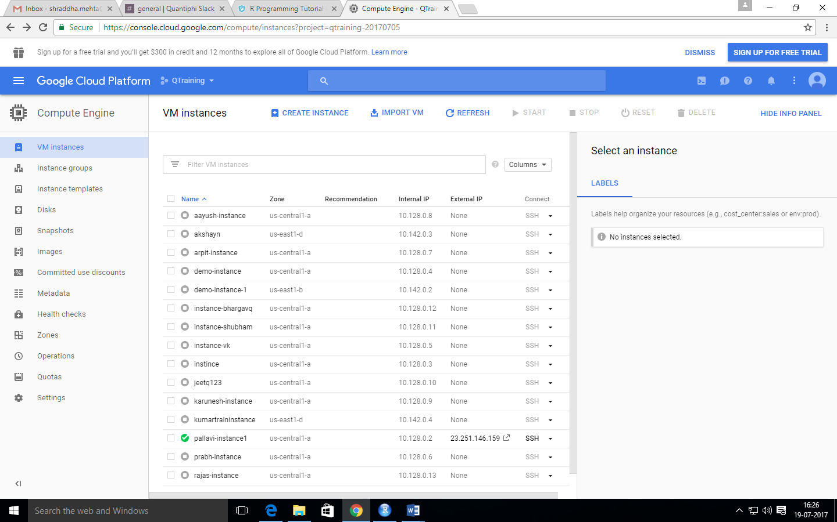

Step 3: Enter details of your instance

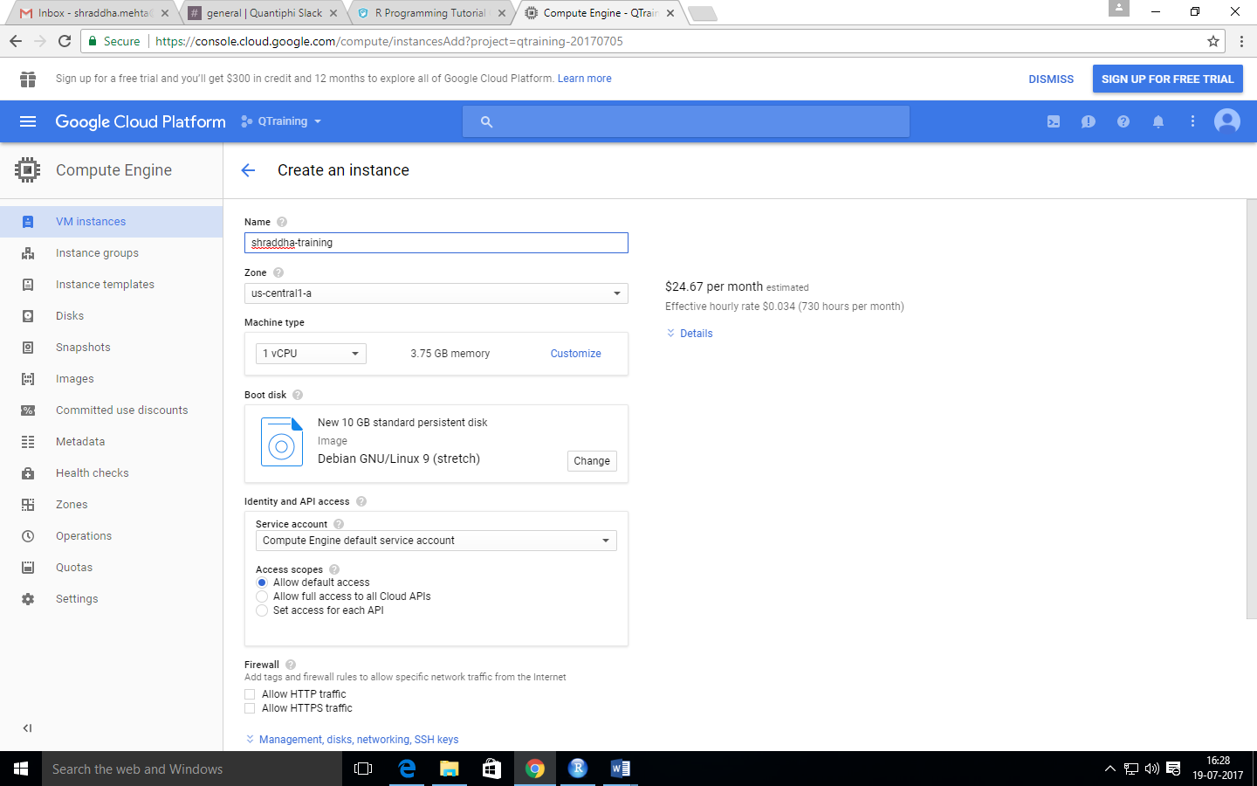

Step 4: Click on create

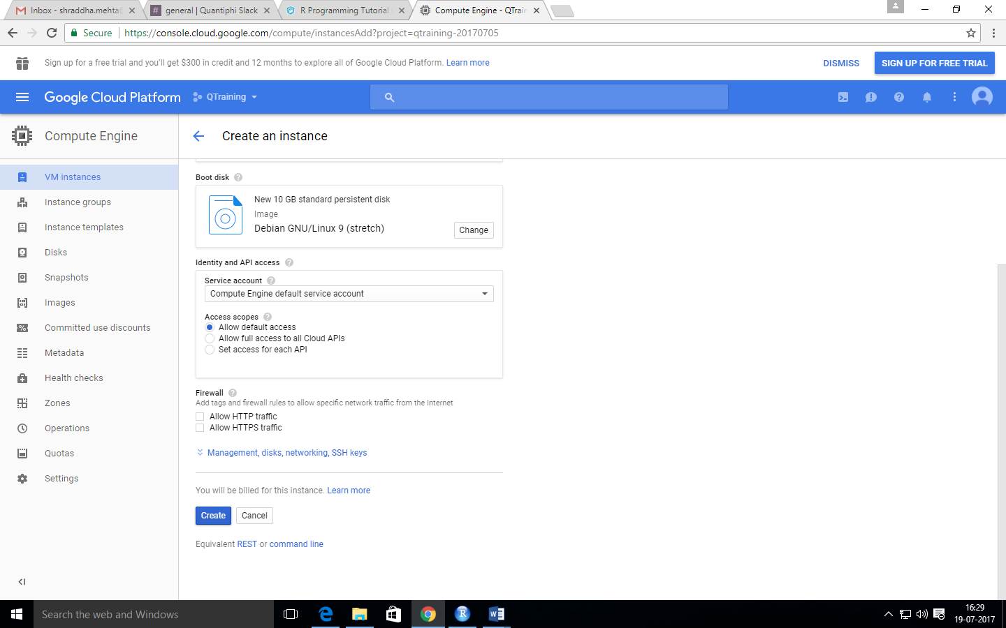

Step 5: Add relevant labels

